INTELLIGENT PERSONALIZED AI ADAPTIVE TUTOR – IMPLEMENTATION OF PIPELINE USING SIMULATED DATA
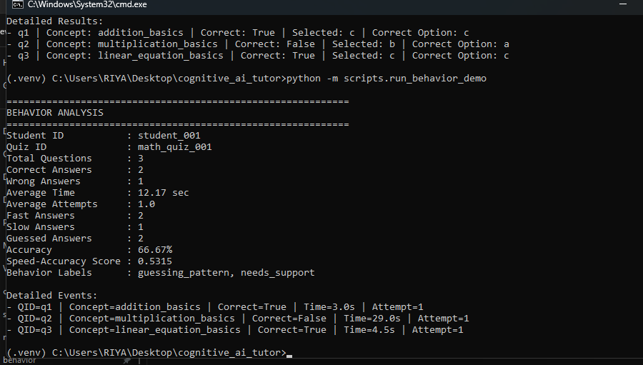

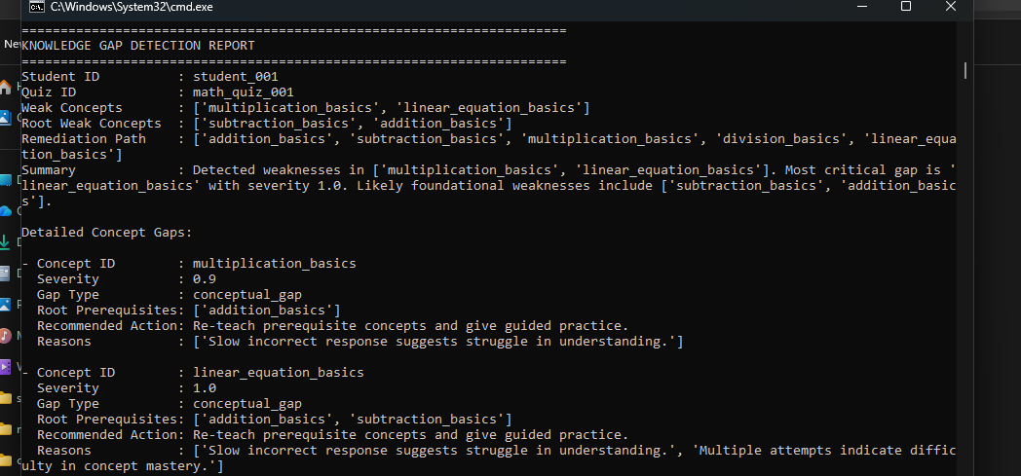

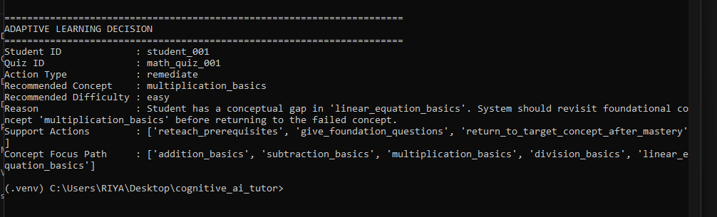

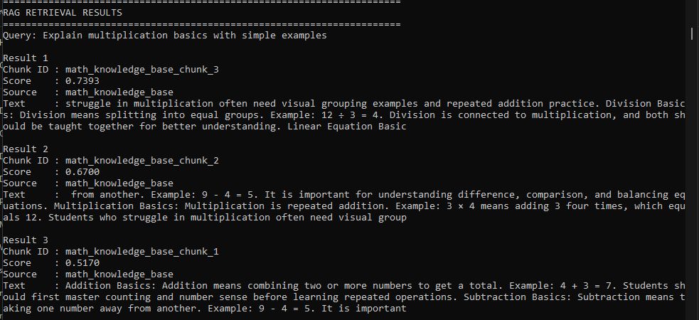

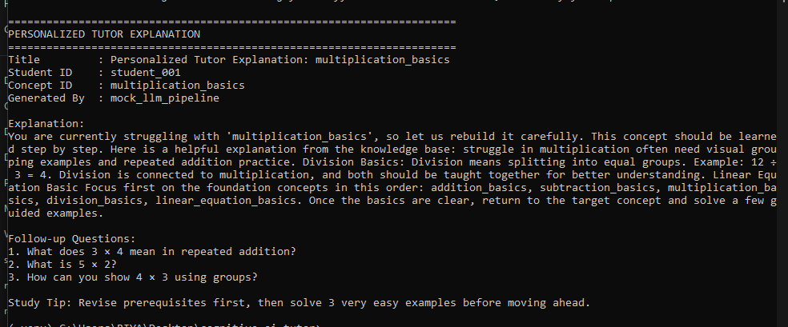

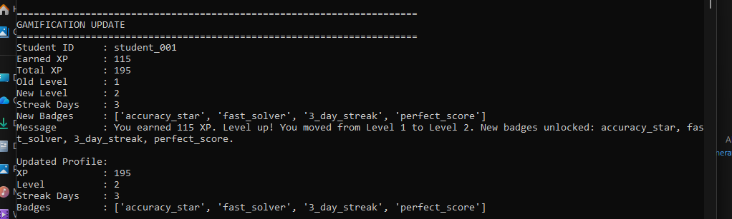

PROPOSED MODEL ARCHITECTURE
